Specifications-2: Freescale MKM34Z128CLL5 ARM Cortex M0+ controller

* Core: ARM Cortex M0+
* Data bus width: 32-bit
* Maximum clock frequency: 50 MHz
* Program memory size: 128 Kb
* Data RAM size: 16 kB
* A/D bit size: 24-bit sigma-delta ADC with PGA, 12 channel 16-bit SAR ADC
* Operating supply voltage: 1.71 V to 3.61 V
* 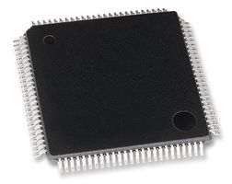Max. operating temperature: +85’ C
* Package: LQFP 100
* Data RAM type: RAM
* Data ROM size: 128 kB
* Data ROM Type: Flash
* Interface Type: 2-I2C, 2-SPI, 4-UART
* On chip DAC: with DAC
* LCD Segment driver (up to 288)
* High accuracy RTC (+-% PPM)
* Two internal clock reference:
  + 32 kHz
  + 2 MHz

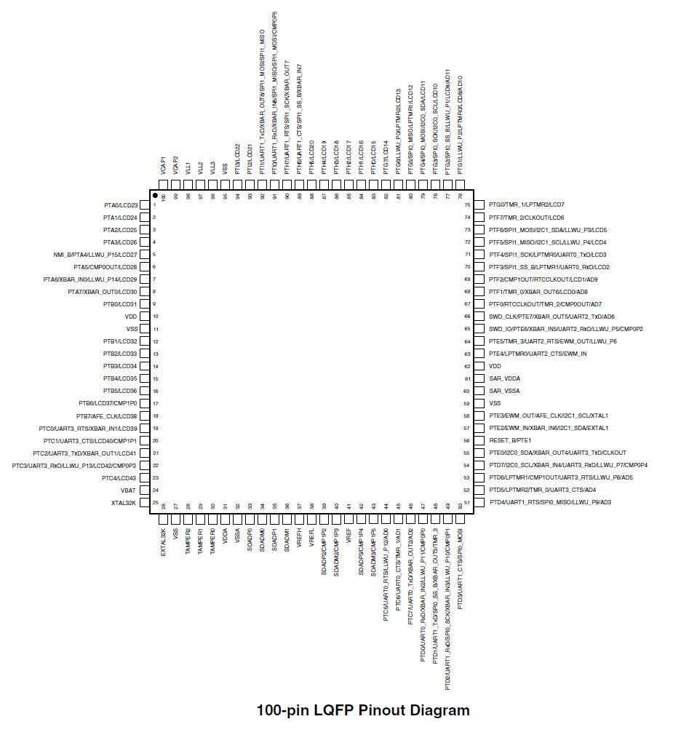

Specifications-3: FTDI FT232RL (USB Host IC)

Specifications [12]

* Single chip USB to serial data interface
* 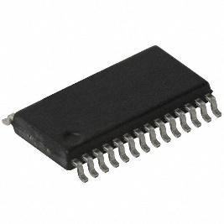Entire USB protocol on chip
* Data transfer rates from 300 baud to 300 Megabaud
* Clock output signals for driving external MCU
* FIFO transmit and receive buffers for high data throughput
* 1024 bit EEPROM for storing device descriptors
* Integrated +3.3V level converter for USB I/O
* Package: SSOP-28, QFP-32